**Source Code:**

clc

clear

clf

e=1.6e-19;k=1.38e-23

u=0

E=-0.5:0.001:0.5

T=100:200:900

T0=300

dist=['Bose Einstein','Maxwell Boltzmann','Fermi Dirac']

a=-1

for n=1:3

for j=1:length(T)

for i=1:length(E)

if T0==T(j)

q=j

end

l(j,i)=(exp(((E(i)-u)*e)/(k*T(j)))+a)

f(j,i)=1/l(j,i);

end

end

a=a+1

subplot(2,2,n)

plot(E',f','linewidth',4)

ylabel('f(E)','fontsize',4)

xlabel('Energy(eV)','fontsize',4)

legend('T='+string(T)+'K')

title(string(dist(n))+'distribution fr u='+string(u),'fontsize',5)

C(n,:)=f(q,:)

end

subplot(2,2,4)

plot(E',C','linewidth',4)

ylabel('f(E)','fontsize',4)

xlabel('Energy(eV)','fontsize',4)

legend(string(dist)+'distributio',3,3)

title(string('Temperature='+string(T(q))+'E','fontsize',5))

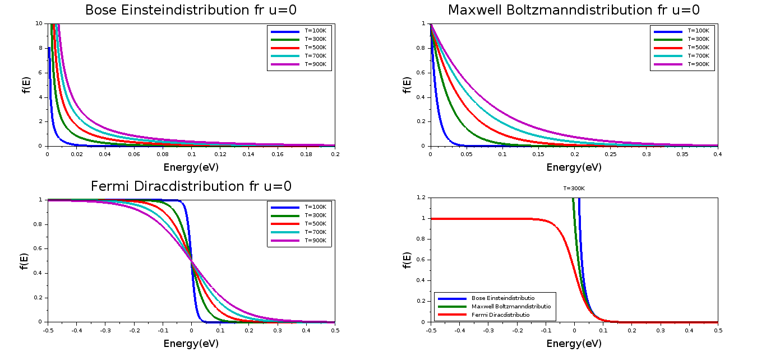**Output:**